**Assignment**

**CSA0841 – Python Programming**

|  |  |
| --- | --- |
| **Register Number** | **192371076** |
| **Name** | **Lahari Venkatesh Yegi** |

**Title:** **Code Snippet Manager**

**Problem Statement:**

Implement a Python program that organizes and categorizes code snippets from various programming languages in a searchable database or file, allowing users to add, edit, and retrieve snippets based on tags or keywords.

**Code:**

py

import json

def create(tags, snippet):

r = {}

r[json.dumps(tags)] = snippet

with open('./data.json', 'w') as f:

f.write(json.dumps(r))

def read(tag):

with open('./data.json', 'r') as f:

for k, v in json.load(f).items():

for t in json.loads(k):

if t == tag:

return v

def update(tag, snippet):

with open('./data.json', 'r') as f:

r = json.load(f)

for k, v in r.items():

for t in json.loads(k):

if t == tag:

r[k] = snippet

break

with open('./data.json', 'w') as f:

f.write(json.dumps(r))

def delete(tag):

with open('./data.json', 'r') as f:

r = json.load(f)

for k in list(r.keys()):

for t in json.loads(k):

if t == tag:

del r[k]

break

with open('./data.json', 'w') as f:

f.write(json.dumps(r))

def list_all():

with open('./data.json', 'r') as f:

return json.load(f)

def search(query):

with open('./data.json', 'r') as f:

r = json.load(f)

return {k: v for k, v in r.items() if query in k or query in v}

print('Welcome to Snippet Manager!')

print('1. Create a new snippet')

print('2. Read a snippet')

print('3. Update a snippet')

print('4. Delete a snippet')

print('5. List all snippets')

print('6. Search snippets')

print('7. Exit')

while True:

choice = input('Enter your choice: ')

if choice == '1':

tags = input('Enter tags separated by commas: ').split(',')

snippet = input('Enter snippet: ')

create(tags, snippet)

elif choice == '2':

tag = input('Enter tag: ')

print(read(tag))

elif choice == '3':

tag = input('Enter tag: ')

snippet = input('Enter snippet: ')

update(tag, snippet)

elif choice == '4':

tag = input('Enter tag: ')

delete(tag)

elif choice == '5':

print(list_all())

elif choice == '6':

query = input('Enter query: ')

print(search(query))

elif choice == '7':

print('Goodbye!')

break

else:

print('Invalid choice!')

**Output Screen Shots:**

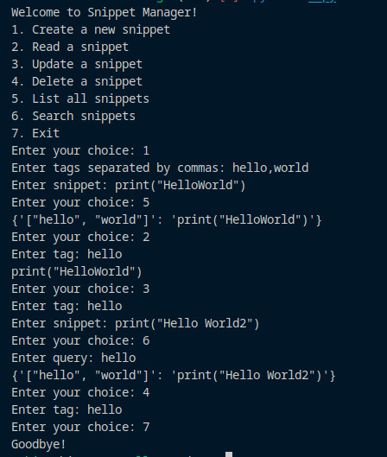

**Conclusion:**

I have converted the list of tags into a string with the json.dumps to make the tags easily accessible and made the best use of storage to get this logic makes it really efficient to store the snippets in another json file. This program can easily create update search and list all the snippets in the json file efficiently with the best usage of storage